ASTR 28200 Assignment #1

Alejandro Legarda

4/8/16

**Problem 1**

**a)**

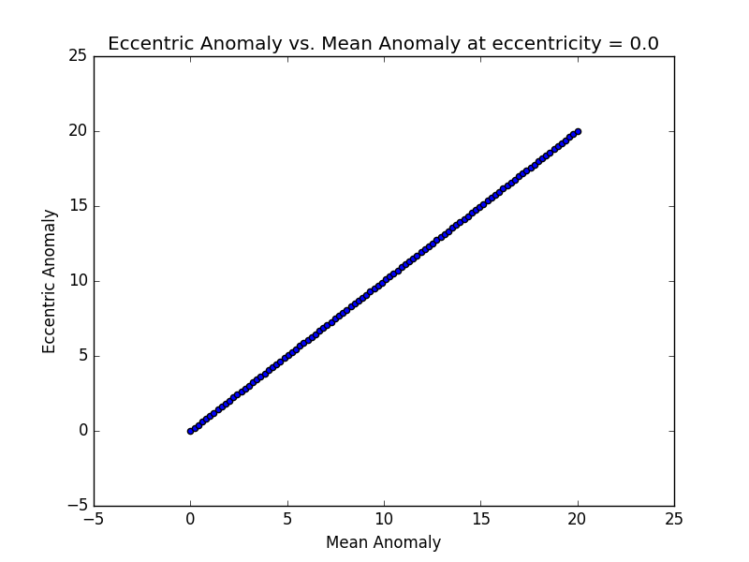

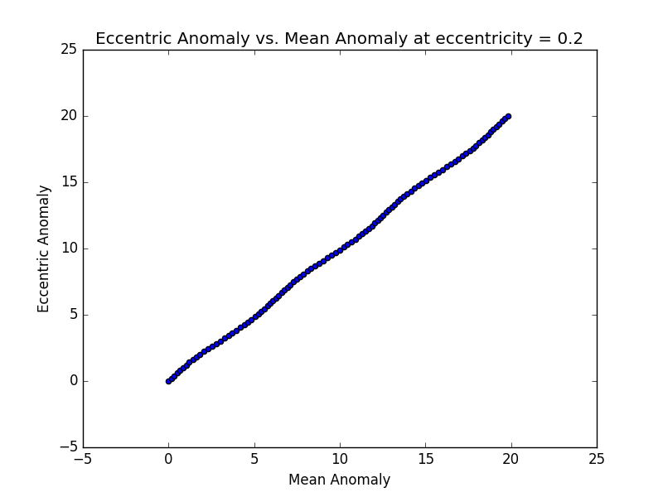

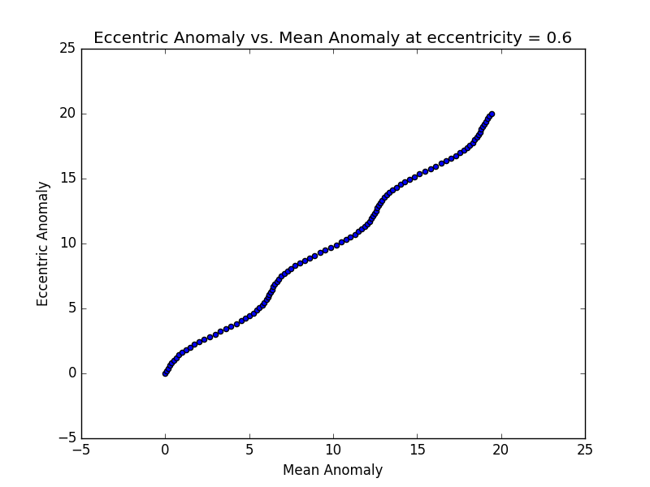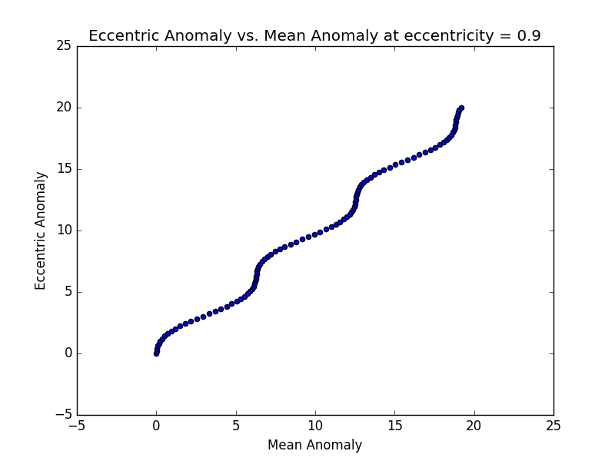

**b)**

We use the following equation to approximate E, where M=0.95 and e=0.9, and the zeroth-order E=0.



|  |  |  |  |  |  |  |  |  |  |  |  |
| --- | --- | --- | --- | --- | --- | --- | --- | --- | --- | --- | --- |
| Iteration | 1 | 2 | 3 | 4 | 5 | 6 | 7 | 8 | 9 | 10 | 11 |
| E | 9.5000 | 4.9583 | -1.2926 | 0.5368 | 4.3915 | 1.0456 | 2.2903 | 1.8739 | 1.8227 | 1.8217 | 1.8218 |

**c)**

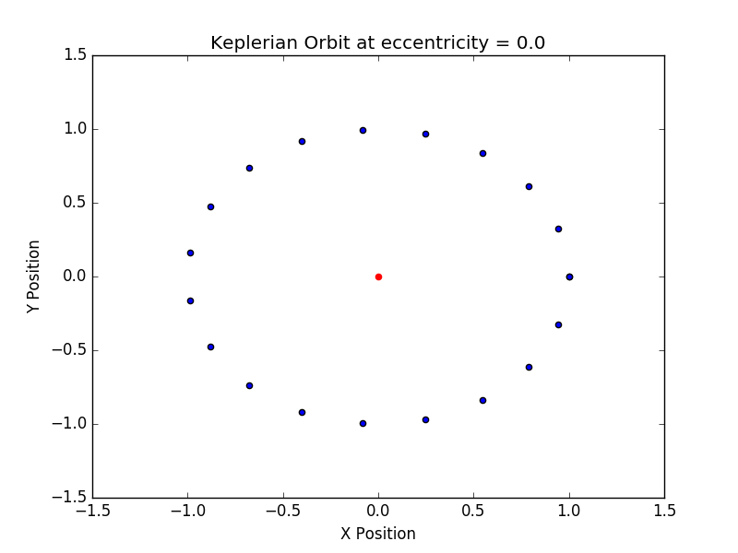

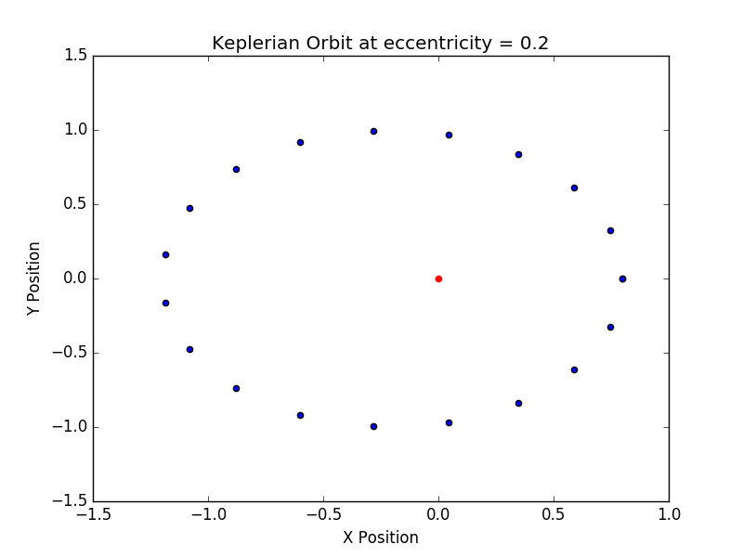

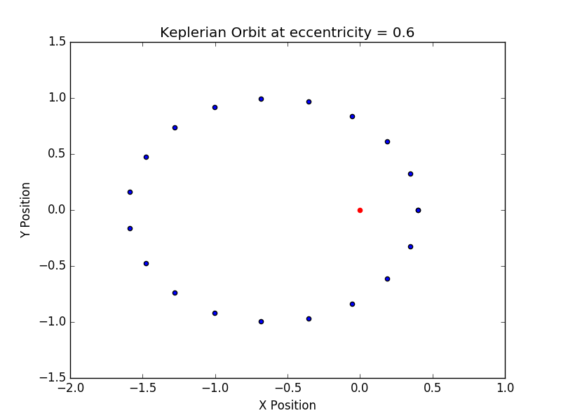

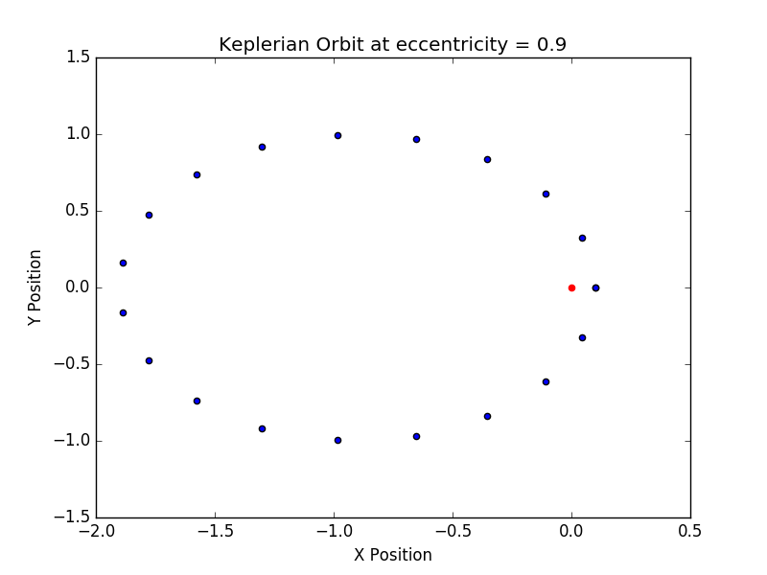

The area swept out in any interval on a given plot is always the same – in accordance with Kepler’s second law. When the area, or wedge, looks small (short), this is compensated for by a faster orbital velocity, resulting in the same area swept in a fixed period of time, regardless of position on an orbit. This holds for any bound orbit.

**Problem 3**

**a)**

The three different websites contain primarily the same data, but interact with it differently. The second two websites are useful because they allow more customization of the table – one can add or subtract columns of data, whereas in exoplanets.eu you have the option of a compact or full (and overwhelming) view. The other main difference is in plotting. Openexoplanetcatalogue.com is very nifty and provides a few useful python scripts. Exoplanets.org has a very precise but simple plotter. Exoplanets.eu produces professional looking plots. Given the choice I would pick Openexoplanetcatalogue.com because of its modularity and potency (and modern aesthetics + python stuff) – it appears to be the modern alternative.

**b)**

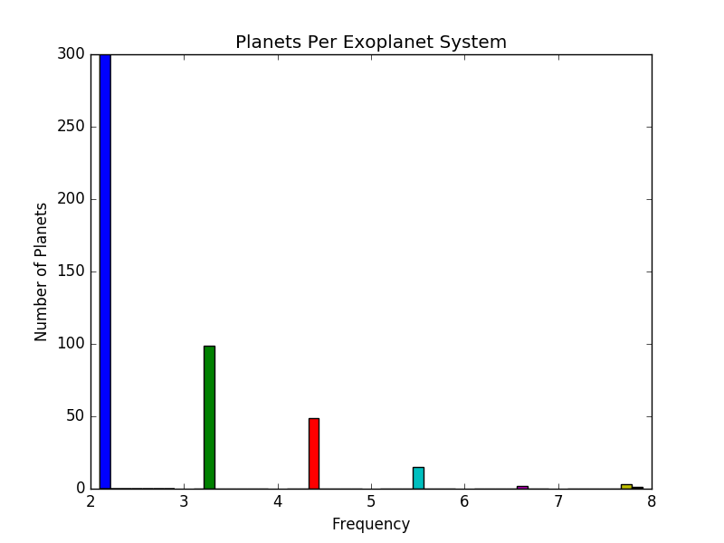

**c)**

Single planet systems are detected primarily by the transit and RV methods. Imaging and microlensing were also used. The RV and transit methods are used almost exclusively when discovering Systems (and the planets thereof) with more than 2 planets.

The transit method excels for larger planets and closer orbit, i.e., it is easier when the degree of occlusion is greater. When there exists a higher number of planets in a system, this increases the probability of larger planets and close orbits, due to natural distribution, and increases the probability of occlusion from the perspective of the Earth.

In the case of radial velocity detection methods, these rely on gravitational interaction between the planet(s) and the star(s). The larger and more numerous the planets are, the more observable the RV shifts will be, making it a good detection method for high population systems.

Imaging works better for 1 or 2 planet systems because planets are very faint sources of light. These systems typically have smaller, and hence fainter stars, such that the light from the planets is not completely overwhelmed. It also works well in systems dominated by a single massive planet.

Microlensing also works best with single massive planets. It relies on a highly improbable alignment of two stars and a planet. It works best for planets with wide orbits (ideally at the time of lensing the planet is as far away form its star as possible), and low-mass systems tend to have looser orbits. It works for very distant stars, but only leads to a single discovery, due to the rarity of the lensing event, so it is highly likely that systems where we have discovered a single planet using microlensing have other planets that we are too far away from to detect using other methods.

**d)**

Will ask for extension/explanation.